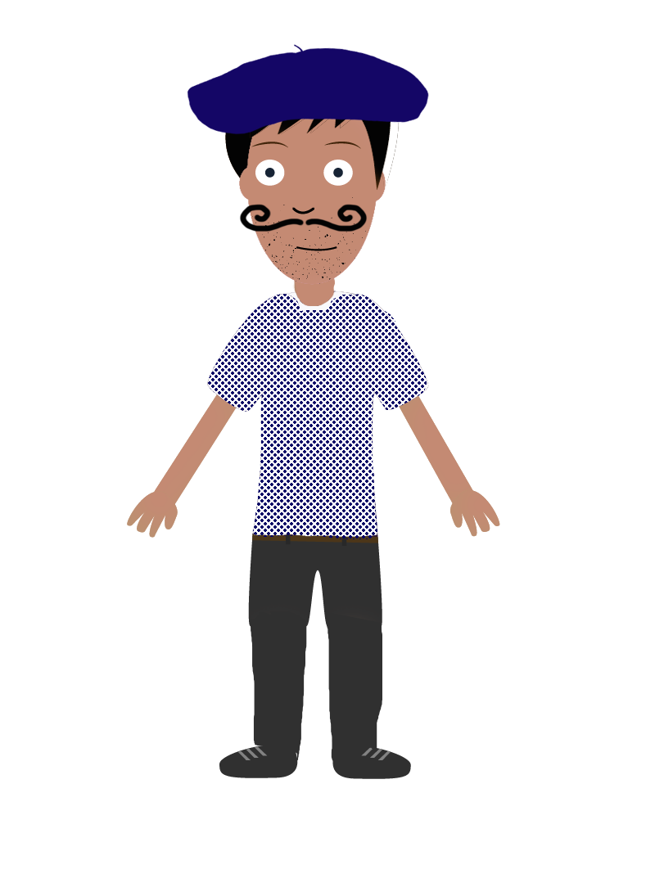
REGULAR ER VERBS
PRESENT TENSE
VERB LIST
These verbs all follow the normal rules for ER verbs.
abandoner | To abandon | exprimer | To express
accrocher | To attach / hang | gagner | To win
admirer | To admire | garder | To look after / keep
aider | To help | goûter | To taste
aimer | To love / like | habiter | To live
allumer | To turn on / to light | imaginer | To imagine
amuser | To amuse | jouer | To play
apporter | To bring | laisser | To leave
arriver | To arrive | laver | To wash
attacher | To attach | louer | To rent / hire
attirer | To attract | marcher | To walk
attraper | To catch | monter | To go up / climb
briller | To shine | oser | To dare
cacher | To hide | oublier | To forget
casser | To break | parler | To speak / talk
chanter | To sing | passer | To spend time / pass
chercher | To look for | porter | To carry / wear
commander | To order | préparer | To prepare
compter | To count | présenter | To present / introduce
décider | To decide | quitter | To leave
déjeuner | To have lunch | refuser | To refuse
dessiner | To draw | regarder | To watch
dîner | To dine | rencontrer | To meet
donner | To give | rester | To stay
Je ____________ e
Remove ER to get your stem and then add the following endings:

regarder = regard
Tu _____________es
Il / elle ____________e
Nous _____________ons
Vous _____________ez
Ils / elles _____________issent Ils / elles _____________ent
fermer | To close | retourner | To return
fouiller | To rummage | sauter | To jump
échapper | To escape | tomber | To fall
écouter | To listen | toucher | To touch
embrasser | To kiss | travailler | To work
enseigner | To teach | traverser | To cross
entrer | To enter | tromper | To deceive
épouser | To marry | utiliser | To use
étudier | To study | visiter | To visit
expliquer | To explain

Verbs with spelling changes:
Verbs ending in CER (CER = çons but ONLY in the nous form)
avancer | To advance | Nous avançons
commencer | To start | Nous commençons
lancer | To throw / launch | Nous lançons

Verbs ending in GER (GER = eons but ONLY in the nous form)
changer | To change | Nous changeons
manger | To eat | Nous mangeons
partager | To share | Nous partageons
nager | To swim | Nous nageons
voyager | To travel | Nous voyageons

Verbs ending in OYER, UYER and AYER(Y = i EXCEPT in the nous and vous forms)
balayer | To sweep | Je balaie
employer | To employ | J’emploie
ennuyer | To bore | J’ennuie
envoyer | To send | J’envoie
essayer | To try | J’essaie
nettoyer | To clean | Je nettoie
payer | To pay | Je paie

Verbs with é in the penultimate syllable (EXCEPT in the nous and vous form)
célébrer | To celebrate | Je célèbre
compléter | To complete | Je complète
espérer | To hope | J’espère
préférer | To prefer | Je préfère
protéger | To protect | Je protège

Specific verbs in which e becomes è (EXCEPT in the nous and vous form)
acheter | To buy | J’achète
enlever | To remove | J’enlève
lever | To raise | Je lève
mener | To lead | Je mène
peser | To weigh | Je pèse
promener | To walk | Je promène

Verbs doubling the final consonant (EXCEPT in the nous and vous form)
appeler | To call | J’appelle
jeter | To throw | Je jette

