THE PERFECT (PAST) TENSE
Nom:_______________________________________

The Perfect Tense is a Past Tense
It is used for: completed actions in the past.
avoir
Yesterday I watched a film.
Hier j’ai regardé un film.

It is formed with the present tense of avoir + the past participle

J’ai mangé
Past participle
avoir
It is just like the English I have eaten.
Here is how you get the past participle:
er é ir i re u

1 | 2 | 3
J’ | ai | mangé
SUBJECT  Person doing the action | AVOIR  The auxiliary or helping verb  In the present | PAST PARTICIPLE  The main verb. It stays the same all the way through

Now conjugate these verbs in the perfect tense

manger | finir | vendre
J’_______________ | J’__________________ | J’___________________
I have eaten / I ate | I have finished / I finished | I have sold / I sold
Tu __________________ | Tu_________________ | Tu____________________
You have eaten / you ate | You have finished / you finished | You have sold / You sold
Il / elle__________________ | Il / elle_______________ | Il / elle_________________
He / she has eaten / He / she ate | He has finished / He finished | He has sold / He sold
Nous___________________ | Nous___________________ | Nous____________________
We have eaten / we ate | We have finished / we finished | We have sold / We sold
Vous___________________ | Vous___________________ | Vous___________________
You have eaten / you ate | You have finished / you finished | You have sold / You sold
Ils / elles________________ | Ils / elles________________ | Ils / elles________________
They have eaten / they ate | They have finished / they finished | They have sold / They sold

Now put the correct verb in the correct place in the box:
Vendre / finir / travailler / manger / répondre / regarder / jouer / attendre / laver / acheter / écouter / dormir / chercher / visiter / choisir / voyager
Er verbs | Ir verbs | Re verbs
To travel | To choose | To sell
To look for | To finish | To reply
To watch | To sleep | To wait
To visit
To wash
To buy
To listen

Now translate the following:
Ex 1:
- I watched ___________________________________
- He watched ___________________________________
- We listened ___________________________________
- She travelled ___________________________________
- They (masc) bought __________________________________
- You (pl) looked for ___________________________________
- You (sing) visited ____________________________________
- I finished ____________________________________
- We slept _____________________________________
- She sold ____________________________________
- David waited ______________________________________
- David and John replied___________________________________
And now this:
Ex 2:
- Nous avons attendu le bus______________________________________
- Ils ont regardé le film __________________________________________
- Nous avons répondu à la lettre ___________________________________
- Tu as visité le château ___________________________________________
- Elle a fini ses devoirs ____________________________________________
- Vous avez vendu la maison_______________________________________
- J’ai lavé la voiture _____________________________________________
- Aisha a choisi le film ___________________________________________
- Claude a dormi _______________________________________________
- David et Aisha ont cherché les clés ________________________________
Past tense time expressions
Re-write the correct time expression in English next to the correct French.
Hier |  | Last week
La semaine dernière |  | Two months ago
Il y a deux jours |  | Last year
Il y a deux mois |  | yesterday
Il y a trois ans |  | Three years ago
L’année dernière |  | When I was six
Quand j’avais six ans |  | Two days ago
Hier soir |  | Yesterday evening
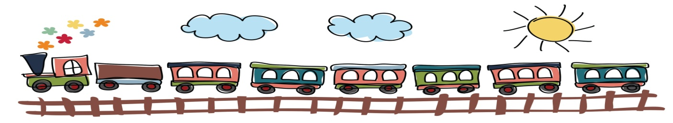
Now translate the following:
Ex 3.
- Last week I watched a film at the cinema (au cinema).
- Three years ago he sold the castle.
- When I was four years old I visited Paris.
- Yesterday evening I slept.
- Two days ago, I waited for the train.
Now the irregulars – put the past participle in the correct box than translate the example
infinitif | Particpe passé | Example use
écrire | écrit | I wrote | J’ai écrit
boire |  | I drank
prendre |  | I took
voir |  | I saw
lire |  | I read
faire |  | I did / made
dire |  | I said
être |  | I was
devoir |  | I had to
pouvoir |  | I was able
mettre |  | I put (on)
savoir |  | I knew
avoir |  | I had
recevoir |  | I received
croire |  | I thought
ouvrir |  | I opened
offrir |  | I gave
été écrit eu ouvert offert
vu dit fallu pris
pu reçu lu fait
dû bu mis su
cru offert

And negative? The negation sandwich goes around the helping verb.
J’ai regardé un film.
Note that in the negative ‘un’ ‘une’ or ‘des’ should become ‘de’
Je n’ai pas regardé de film.
Try putting the following into the negative.
- J’ai mangé une salade. _______________________________
- J’ai acheté un manteau. ______________________________
- Elle a travaillé.______________________________________
- Harry a regardé un film au cinéma.
____________________________________________________________
- Ils ont nagé dans la piscine. ____________________________________________
- Vous avez fait de la lèche-vitrine.
Remember the following negatives work in exactly the same way :
ne…pas not
ne…que only
ne…jamais never
ne...rien nothing
ne...plus no longer
THE PERFECT TENSE WITH ÊTRE
So now you know the perfect tense…well nearly.
There are 14 verbs which have a catch.
- They don’t use avoir as the helping verb. They use être.
- They need to agree.
Je _____________
Tu ____________
Il / elle / on ____________
Nous ____________
Vous ______________
Ils / elles ______________
So first conjugate être
as you would in the present.

être
Let’s take the verb ‘aller’ (to go). This is one of the verbs that take être in the past tense. We want to say ‘I went.’
So: J’ai allé
Je suis allé
So how would you write: ‘He went’ __________________________________
The following are the verbs that take être instead of avoir.
There are different ways to remember them.
You can try Mrs Vandetramp…
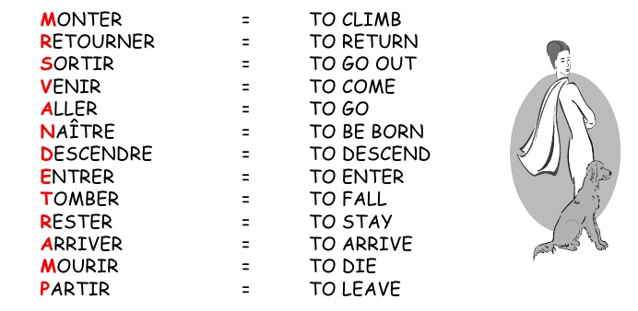
Or you can learn the in opposites as castle verbs: 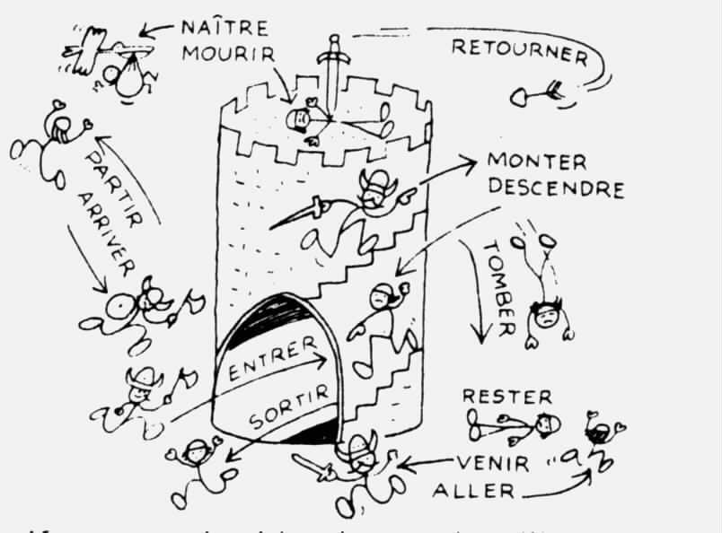
So now try translating the following:
venir (to come) venu
revenir (to come back) revenu
devenir (to become) devenu
mourir (to die) mort
naître (to be born) né
- He entered __________________
- He left _________________
- He went up / got on _________________
- He fell __________________
- He went out __________________
- He stayed __________________
- He was born ___________________
- He died __________________
- He came __________________
- He became ___________________
Here’s the catch. All verbs that take être have to agree in number and gender.
Look at the example and work out what we are doing in terms of grammar:
Nous sommes allées
Nous sommes allés
Je suis allée
Je suis allé

Yes. For feminine singular we add ‘e’ masculine plural ‘s’ and feminine plural ‘es’ to the past participle.
Il est monté Elle est montée Ils sont montés Elles sont montées

Now look at the list of all the être verbs with their possible agreements:
IF THEY ARE NOT ON THIS LIST USE AVOIR
REGULAR ER IR RE VERBS
Monter (to go up / get on) montées (went up)
Descendre (to go down / get off) descendues (went down)
Entrer (to enter) entrées (entered)
Sortir (to exit) sorties (went out)
Partir (to leave) parties (left)
Retourner (to return) retournées (returned)
Aller (to go) allées (went)
Tomber (to fall) tombées (fell)
Rester (to stay) restées (stayed)
IRRREGULAR VERBS
Venir (to come) venues (came)
Revenir (to come back) revenues (came back)
Devenir (to become) devenues (became)
Mourir (to die) mortes (died)
Naître (to be born) nées (was born)

Using the box of verbs and possible agreements for help, translate the following:
- Je suis monté. _____________________________
- Elle est descendue. _____________________________
- Elles sont descendues. _____________________________
- Vous êtes partis. _____________________________
- Je suis montée. _____________________________
- Nous sommes nées. _____________________________
- Elizabeth est sortie. ______________________________
- Elizabeth et Arthur sont sortis. ______________________________
And now into French :
- Dave went. _____________________________
- I (fem) went. _____________________________
- We (masc) entered. _____________________________
- She went up. _____________________________
- They (fem) became _____________________________
- David and Jemima fell. _____________________________
- You (fem pl) came back. _____________________________

